**EasyShop**

J Component Final Report

Internet and Web Programming

*Submitted By: -*

**18BCE0957 Divyansh Mantri**

**18BCI0190 Laksh Gupta**

**18BCI0197 Nimish shah**

*Guided By: -*

**Prof.Nalini N.**



**Vellore-632014, Tamil Nadu, India**

**School of Computer Science and Engineering**

# Abstract

Due to the coronavirus pandemic we all have been confined to our homes. People are not heading out un-necessarily, but getting groceries is important and going to multiple shops can be dangerous.

Also due to the pandemic there is a disruption in the supply of groceries to the shops, and the customer has no way of confirming whether the thing they want will be in stock or not without calling the shop or going there.

Also there are discrepancies in prices, currently there is no feasible way for a customer to compare the prices of different shops for all the items in their shopping list.

The project allows users to check the inventories of nearby shops. Easyshop is the place where customers can view their day to day products and order them online instead of going there physically. In this project, operators enter the Website and buy some product, we then look at their cart and compare it to all nearby shops available, we then generate the bill for every shop and allow the customer to choose which shop they want to order from. Supervisors and admin will have separate login ID and pin through which they can access their account to modify their inventory, which can be done in real-time giving the customer an accurate view of their inventory.

# Keywords

E-commerce, ReactJS, Google firebase, Javascript, NodeJS, JSON, JWT, Hashing, Encryption,RSA, Blake2b hashing,

# Introduction

we went into lockdown from 25th march 2020, so people were forced to get their groceries from local shops. The ones they could walk to, so we thought that if we could make a web-based application that can help them know the inventory of these shops before they set out of their homes, it would help them shop easily and also save some money and time. This will also help in reducing contact between the shopkeepers and the customers, hence reducing the chance of the spread of covid-19.

First of all the development team will analyse tasks and produce a document of the functionalities minimum of the project and possible features that can be added later.

Then they will discuss and finalize the technologies that are going to be used. A milestone chart will be prepared based on which the final scope and dates(deadlines) will be agreed.

* **Project deliverables**

A web based application that satisfies the points mentioned in the problem statement in a satisfactory manner.

* **Project acceptance criteria**

A website that is able to meet the set criteria.

* **Project constraints**

Application should be ready by end of semester for final review.

We wish to show the users all the shops close to them and allow them to search for the products that they want through the options provided on our website. They should be able to create a cart which contains all the items they wish to buy. Then the website should show the user a comparative analysis of the prices at each shop and the approximate final price for the whole cart for every shop available nearby. The website should also notify the user if a product is not available.

There is also a feature for the customer to send their list to the shop so that the shopkeeper can keep the items ready so that the customer can only pick the groceries quickly.

*This is a completely new project and is not a part of any other ongoing product.*

*A functional overview of the proposed website:*

*Admin profile*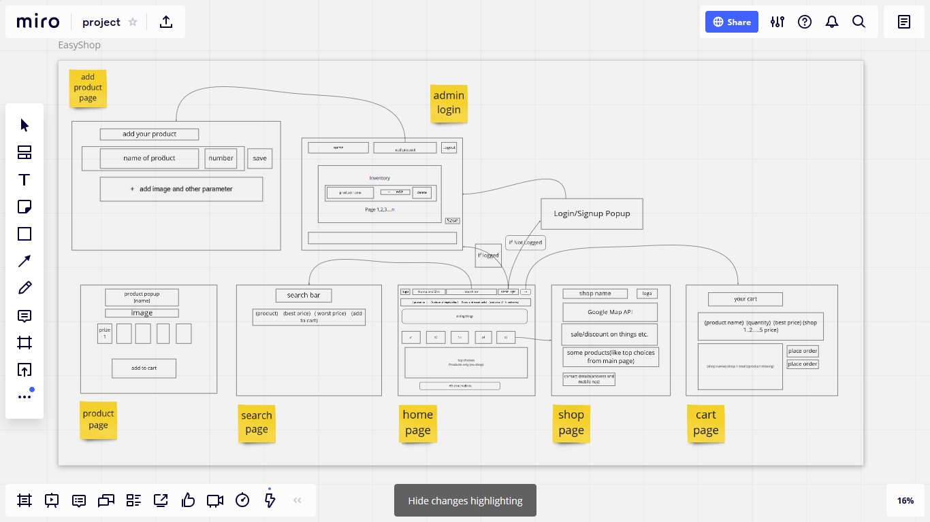

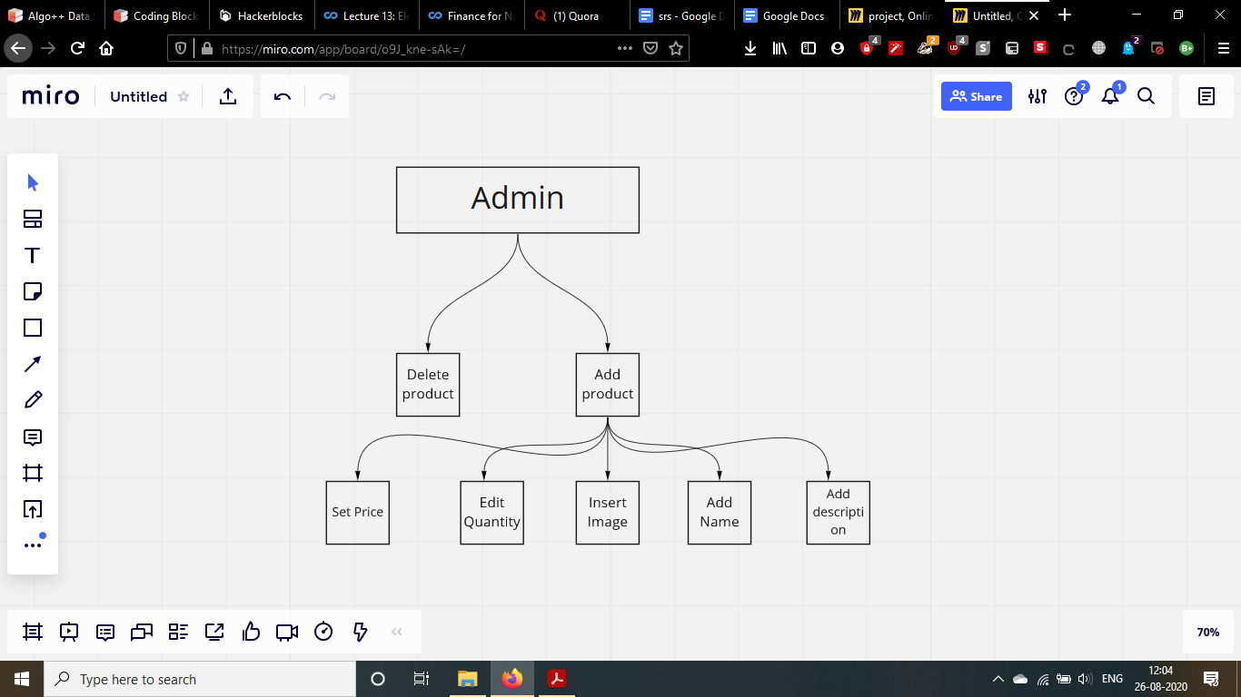

*Customer profile*

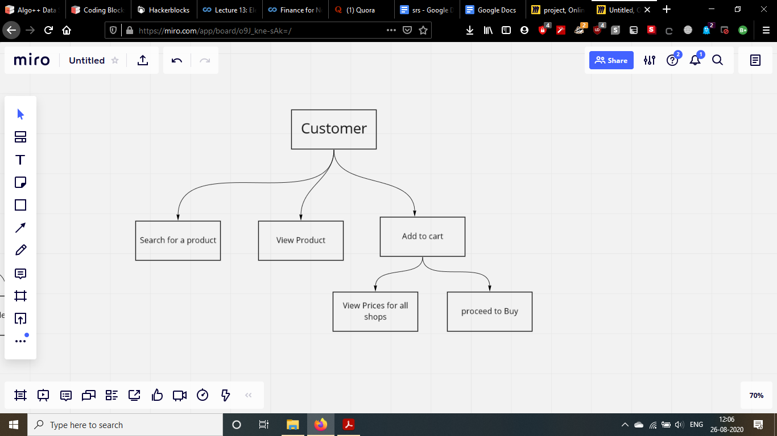

*Customers enter the market and buy some products, we show them the various products that our partner shops offer, allowing them to search and add products in a cart. Then we generate the comparative bill for that customer. Admins will have a separate login ID and pin through which they can access their account and manage their shops inventory in real time.*

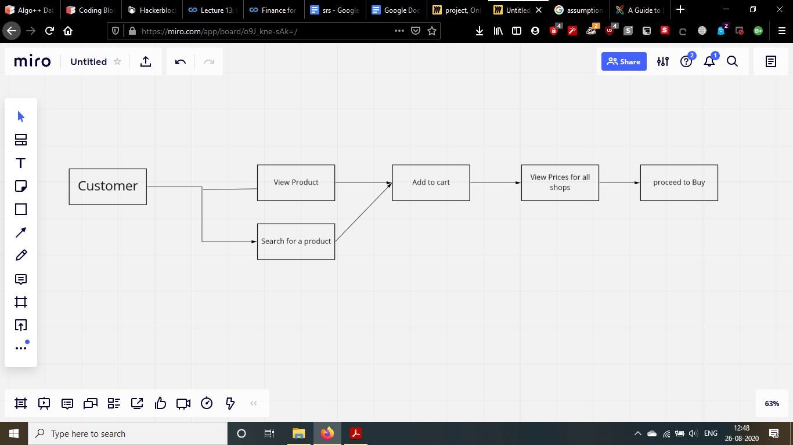

*Performance Requirements*

*The website should be easily accessible via both laptop/desktops and mobile phones as most customers will prefer to order via their phones.*

*Also the database should be distributed, and NOSQL based so that it can be easily accessed by multiple users simultaneously.  
The website should also feel quick and responsive to the user to give them a convenient shopping experience.*

*Safety Requirements*

*The password of admins i.e the shopkeepers are being stored in hashed format instead of plain text format in the database. For this, we are using the blake2b hashing algorithm.*

*The hashing should be done in such a way that it should be hashed in controller logic itself...not after entering in the database. For that a function is defined which needs to be called while doing CRUD operations with the database.*

*We need to use IP filtering for preventing DDOS attacks on the server to ensure availability from the CIA triad.*

*Use of SSL certificate for establishing secure links between networked computers.*

*Security Requirements*

*Requires the use of RSA to encrypt the form data before sending it on the server. Passwords are protected in the database with the help of Blake2B hashing algorithm.*

*An SSL certificate to ensure secure links between networked nodes.*

*Functional requirement*

*ADMIN*

An admin is a high priority who holds the authority to manage the working of their entire Shop . Also, the admin is in-charge of managing the inventory of their establishments.

*CUSTOMER*

A customer is beneficially a high priority which can be any person who accesses the website and makes the purchase. The website should then connect the customer to the admin of the shop of their choice.

# RELATED WORK/LITERATURE SURVEY

There are a lot of apps/websites who deliver groceries to the customers' doorsteps, but all of them sell their own stock, it means that the products the customers get are brought to them from the company's warehouses. This takes at least one working day, our website differs as we show the available inventory of nearby shops so the customer can go to these shops directly and get the products within a few minutes or they can contact the shops and have the items delivered in less than half an hour as the shops are not very far away.

Current apps/websites available in India are Grofers, Jiomart, Dealshare and Bigbasket.

***Kaur, Navleen. (2020). Business Model - Grofers Determination to Excel in Online Grocery Market in India. 10.13140/RG.2.2.16407.80802.***

Grofers is an affordable online supermarket where you can order and deliver to your doorstep products in categories such as grocery, vegetables, beauty and wellness, household goods, baby products, pet care, meat and seafood. Indian online delivery service, located in Gurugram in Haryana. The company was founded in December 2013.

When a customer orders from the Grofers app, the City of Grofers management team takes this order from the app and sends it to the warehouse. The deliveryman picks the product from the warehouse and delivers it to the customer. All orders for all regions are processed in our warehouse. This process takes almost a day to process an order compared to the 90 minutes on the previous model. Now Grofers do the whole process on their own instead of including third-party sellers. Therefore, it is very unlikely that your order will be fulfilled. The advantage of this model is that intermediaries are eliminated. Grofers is no longer a logistics company, but a company that has opened grocery warehouses in several cities.

# 

# 

# 

# 

# 

# 

# 

# 

# 

# **BUSINESS MODEL OF BIGBASKET**

The Bigbasket story begins in 1999. Founders are VS Sudhakar, Hari Menon, Vipul Parekh, Abhinay Choudhari and VS Ramesh. They started their first online shopping business in India called Fabmart.com. They started their online grocery business in 2001 as part of Fabmart. They also succeeded in building an offline store called Fabmall, a chain of grocery supermarkets in southern India. In 2006 they sold their business. In 2011, the team returned and started Bigbasket.com. Bigbasket.com is available in Bangalore, Hyderabad, Mumbai, Pune, Chennai, Delhi, Noida, Mysore, Coimbatore, Vijayawada-Guntur, Kolkata, AhmedabadGandhinagar, Lucknow, Kanpur, Gurgaon, Vadodara, Visakhapatnam, Surat, Nagpur, Patna, Indore. There is. There is. And Chandigarh Tree City

Model used

Customer purchasing patterns are identified using RFM and clustering methods. The RFM method can display the customer's recent last name, frequency and monetary value. When each customer's RFM value is known, the customer is clustered into groups using K-Means. The clustering method forms several clusters with different RFM values ​​and characteristics. Customers in the same cluster are more likely to show similar buying behavior.

2. Customer clusters can be shaped and profiled differently for all product categories. Each customer can be categorized into different profiles based on product category.

3. The best time to deliver notifications and private messages is near the peak or start time.

## **US patent US20090287570A1**

**Glenn D. Adamousky,Gordon T. Graves**

An Internet e-commerce website provides online content having incentives that motivate consumers to select affiliated Vendors. After purchasing goods or services from the affiliated vendors, consumers view a purchase history and receive credit based on purchase amounts. Credits may be used to enter a Sweepstakes. Consumers are also provided access to local vendors via website links to the local vendors web pages. After completing their purchases, consumers receive scratch cards from the vendor. A consumer logs back onto the e-commerce website, and enters a promotion identifying number from the Scratch card. A consumer's account is credited based on purchases made. The consumer uses the credits to enter a Sweepstakes or other games offered through the website. The sweepstakes is a lottery-style play wherein the consumer picks a desired set of digits using a lottery play slip. The available numbers may correspond to a scheduled state

drawing to ensure integrity.

# ***Method and system for facilitating the anonymous purchase of goods and services from an e-commerce website***

# **A.shooks,K.Hibler**

This paper gives an overview of different types of functionalities that e-commerce websites provide to the customers.It includes systems that allow consumers to purchase goods and services anonymously on e-commerce websites, including an account approval system and database. The database is configured to store multiple trading account numbers. There are multiple records in the database, and each record corresponds to one of the transaction account numbers. There are no records configured to store the buyer's identifying information associated with one of the transaction account numbers. The account approval system is in communication with the database and is configured to receive a request for approval of a purchase transaction having purchase value. The request is tied to one of the trading account numbers.

***Banerjee, Amardeep; Siemens, Franziska (2015) : Logistics of EGroceries. de, In: Kersten, Wolfgang Blecker, Thorsten Ringle, Christian M. 978-3-7375-4059-9***

***(Ed.): Innovations and Strategies for Logistics and Supply Chains: Technologies, Business Models and Risk Management. Proceedings of the Hamburg International Conference of Logistics (HICL), Vol. 20, epubli GmbH, Berlin, pp. 91-116***

Manned courier and customer retention are still the biggest challenges.

For electronic grocery stores. Webvan died due to same-day delivery.

It is one of the pioneers of e-groceries. Reliable delivery of groceries on time

It is a competitive differentiator and increases customer loyalty and moderation.

The importance of the last mile matter. The following work goals

To find out the main factors that characterize the German implementation strategy

Online grocery store that solves last mile delivery issues. Literature analysis

The study of business models forms the basis of the conceptual framework.

Also, interview experts from retailers using both

Business models (e.g. multi-channel grocery stores and pure electronic grocery stores) are carried out.

For practical insight and validation of your work

***Aumasson, J. P., Neves, S., Wilcox-O’Hearn, Z., & Winnerlein, C. (2013, June). BLAKE2: simpler, smaller, fast as MD5. In International Conference on Applied Cryptography and Network Security (pp. 119-135). Springer, Berlin, Heidelberg.***

In this research paper, the author presents the hash function BLAKE2, an improved version of the SHA-3 final candidate BLAKE optimized for software speed. Target applications include cloud storage, intrusion detection or version control systems. BLAKE2 comes with two main features. BLAKE2b is optimized for 64-bit platforms and BLAKE2 is optimized for small architectures. On 64-bit platforms, BLAKE2 is often faster than MD5, but offers similar security to SHA-3: up to 256-bit collision resistance, resistance to length extension, indiscretion with arbitrary oracles, etc. Specifies the parallel version BLAKE2bp. BLAKE2sp up to 4x and 8x faster utilizing SIMD and/or multiple cores. BLAKE2 reduces BLAKE's RAM requirement to 168 bytes, which is smaller than one of the five SHA-3 finalists and 32% smaller than BLAKE. Finally, BLAKE2 provides comprehensive support for tree hashing and key hashing (sequential mode or tree mode).

# ***FUTURE OF E-COMMERCE IN INDIA***

Nisha Chanana, Sangeeta Goele

Published 2012

The e-commerce market is booming and preparing for strong growth in Asia. There are players coming down to a great start. Their success depends on their understanding of the market and the variety of features they offer. This paper provides an overview of the future of e-commerce in India and discusses the future growth segments of e-commerce in India. Discover the various elements required for the future growth of Indian e-commerce. Refers to a wide variety of opportunities for retailers, wholesalers, manufacturers and the public. In this paper we find that overall e-commerce will grow significantly in the coming years in the emerging Indian market.

***Ray, S. (2011). Emerging trend of e-commerce in India: Some crucial issues, prospects and challenges. Computer Engineering and Intelligent Systems, 2(5), 17-35.***

Since 1991, when economic reforms have clearly taken place in India as a result of opening up the economy with the intention of integrating with the world economy, the need to facilitate international trade through policy and policy reforms has become a cornerstone. Trade and economic policies of India.

As part of the information technology revolution, e-commerce (e-commerce) has been widely used in world trade and especially in the Indian economy. With the advancement of technology, there have been changes in the method of business transactions. India is fast becoming the fastest adapter of technology with the current scenario of electronic data exchanges and has taken over towards e-commerce. In this regard, this article seeks to present a snapshot of the evolution of e-commerce business, chronologically, the category of e-commerce business, description of companies involved in e-commerce in India, key features of companies engaged in e-commerce application, both physically and financially. -A framework for the effective dissemination of e-commerce in India to examine the growth of e-commerce, to assess the benefits derived from e-business, to critically analyze the barriers and barriers in emerging e-commerce businesses in India and finally to develop. It is the role of the government to provide a legal framework for e-commerce that allows domestic and international trade to expand their horizons, while protecting all fundamental rights such as privacy, intellectual property, fraud prevention, and consumer protection. .

***Modern Web-Development using ReactJS***

ReactJS is a JavaScript library that is distributed to develop reusable user interface (UI) components. According to React official documentation, here is the definition React is a library for building modular user interfaces. React essentially enables the development of large and complex web-based applications that can change data.Without subsequent page refresh. Used as View (V) in Model-View-Controller (MVC). reaction It abstracts the Document Object Model (DOM) to provide a simple, high-performance, and powerful application. Development experience. React mainly uses NodeJS to render on the server-side and supports native mobile apps. It is provided using React Native. React simplifies boilerplate by implementing one-way data flow So it's much easier than traditional data binding. Despite the few minor drawbacks ReactJS has, it is definitely a game changer. The modern web is becoming more dynamic and user-interactive every day. User experience design trends are constantly changing and evolving. Now the client script only pushes the essential data it needs and ensures a smooth and enjoyable experience is maintained across the entire web. These are today's demands for greater convenience, efficiency and accessibility. ReactJS has powerful features and capabilities to meet the needs of today's trends. In short, I can say that ReactJS will definitely affect the way you write apps for the web.

# PROPOSED WORK

We are using blakeJS,cors,express,node-rsa for modifying the transmission between client-server architecture.

We are using body-parser,cookie-parser,dotenv,json web token,path for back-end development.

We are using reactJS, material-UI, axios, mdb icons, react-router-dom for managing front-end .

*We will be using google maps embedded API (free one) to locate the shops natively on the website.*

**Website Functionalities**

* If you are a user then there is no need to login. You can directly search your wish list.
* On the homepage, there will be a list of shops and specific items that are purchased more often and recommended by users.
* If the user clicks on a particular shop, then the user will be redirected to the shop page. On that page, users can see all details about that shop like location, sale, discount, contact details.
* Users also can use the search bar to add products in cart.
* There will be a page for your cart also. There will be a list of all items that you have selected.
* Then based on the algorithm we will give the best shop to buy groceries
* There will be a login for the shopkeeper to update the inventory.
* There will be an add product page for admin. Via this page admin can update their inventory

**Security Functionalities**

* The passwords for the users (shopkeepers) are stored in an hashed manner before being sent to the firebase database which then encrypts it before storing.
* All the requests made are first encrypted and then sent so then any attacker cannot access the data in transit, and even if they intercept it will be useless for them as they will not be able to decipher it.
* We use new hashing algorithms like blake2b instead of SHA as they are faster and more secure.

We updated our hashing algorithm from sha256 to a faster and secure blake2b hashing algorithm. While both have the same algorithmic time complexity, runtime complexity of blake2b is far more better than sha256. You can see that in the picture below,We also use RSA 3072 bit encryption which is better than standard encryption algorithms.

The public and private keys used in the RSA algorithm are created with “ssh-keygen” which is industry standard for cloud computing. So we can ensure the robustness of private keys that will be used in our application.

* The site hosted is also on HTTPS which is more secure than HTTP.

HTTPS is not stateless protocol, so it can be used to store user sessions across the complete web application.

* The site is immune to most common attacks like Cross-Site Scripting (XSS), SQL injection, path traversal, local file injection and distributed attacks like DOS and DDOS.

**Website design**

***Home Page of the website:***

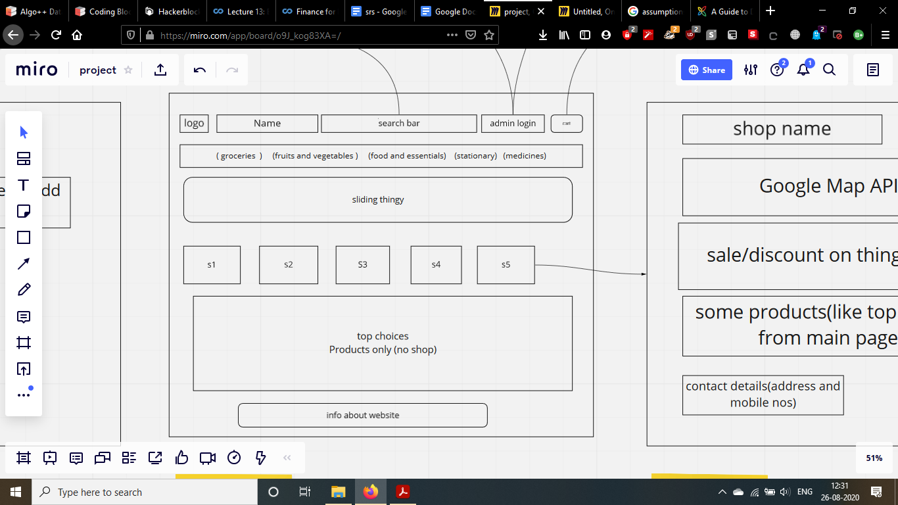

This is homepage of the website, this is where user will come on entering the website

***Product popup page:***

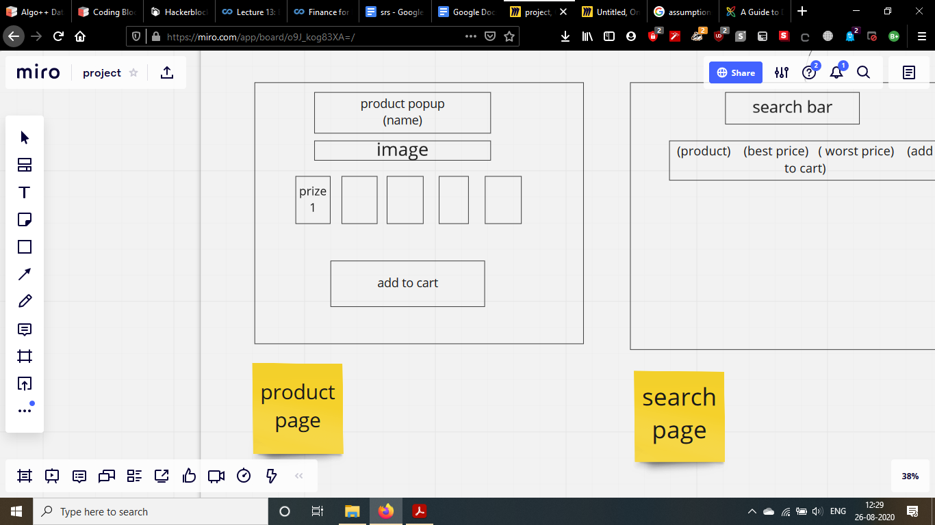

On searching for a product, this page will come. Here, users can select products to add in the cart.

***Shop page:***

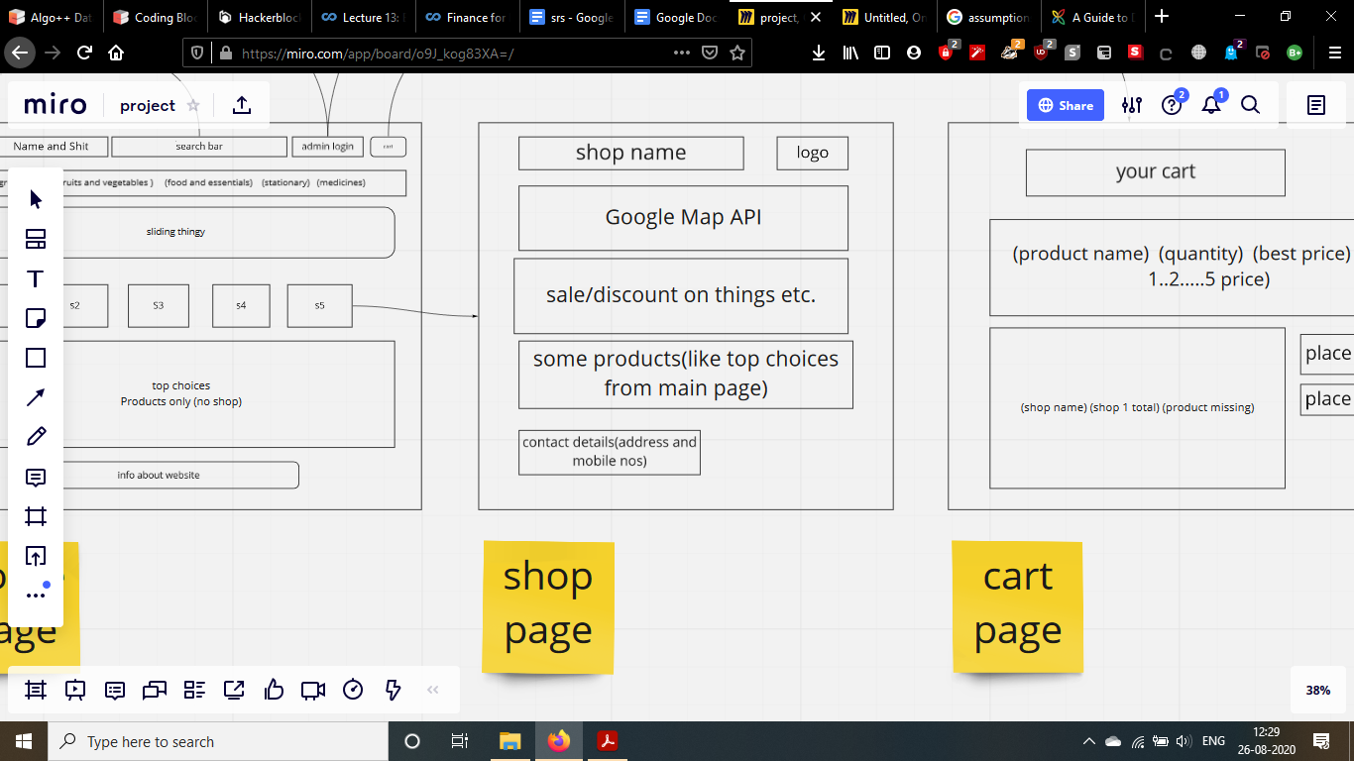

The page shows information about the shop. It will have highlighted products and such.

***Cart page:***

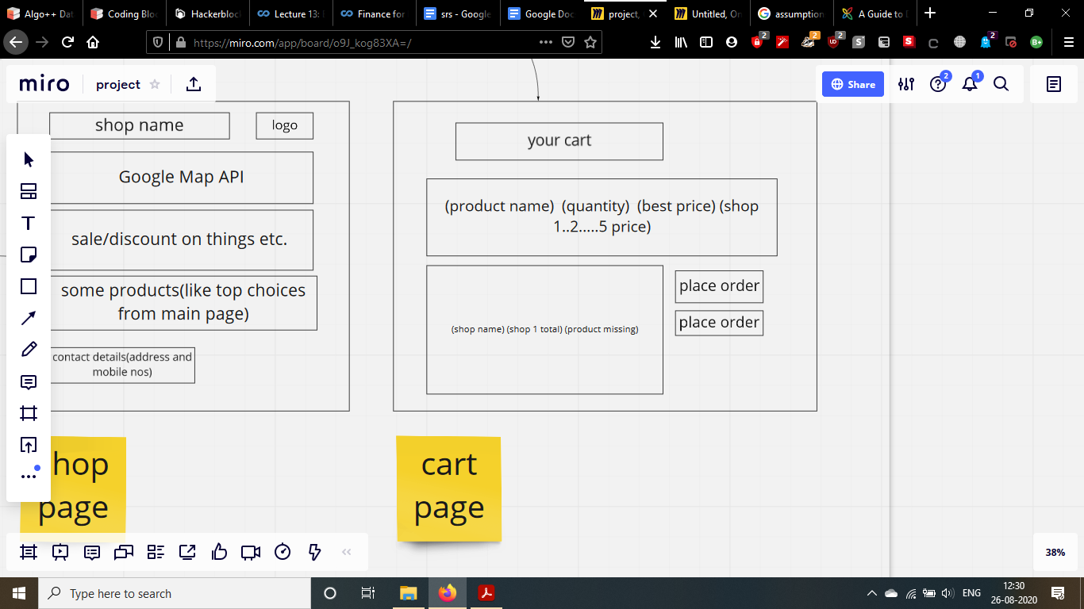

The shopping cart, where user will see selected products

***Search Page:***

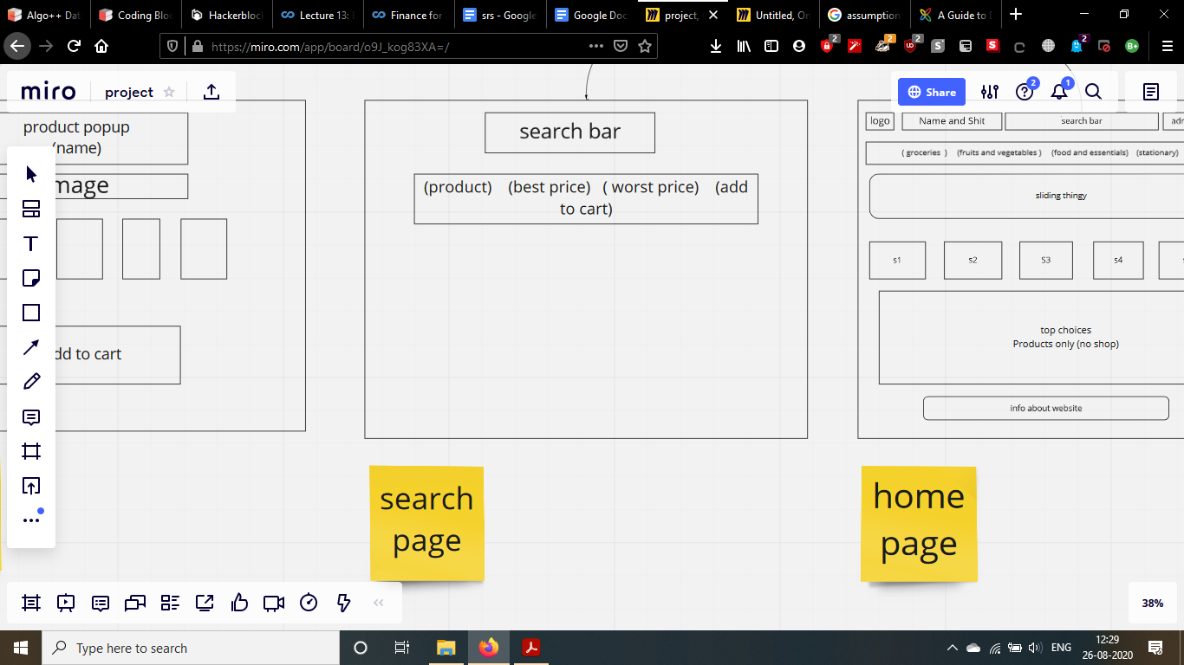

Searched results show up on this page line by line in tabular manner like on an e-commerce website.

***Admin Login:***

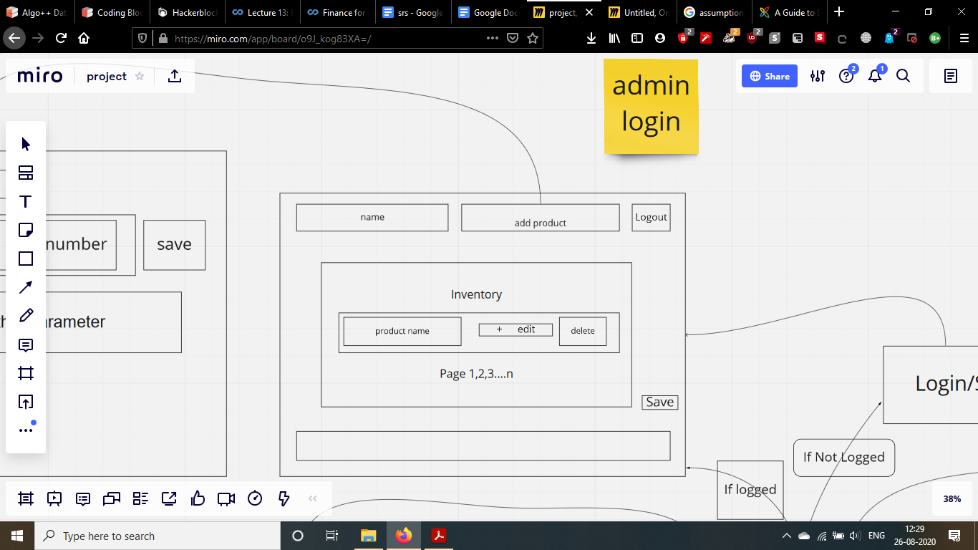

This page is restricted to only shopkeepers. They can manage their inventory with this page

***Admin edit inventory page***

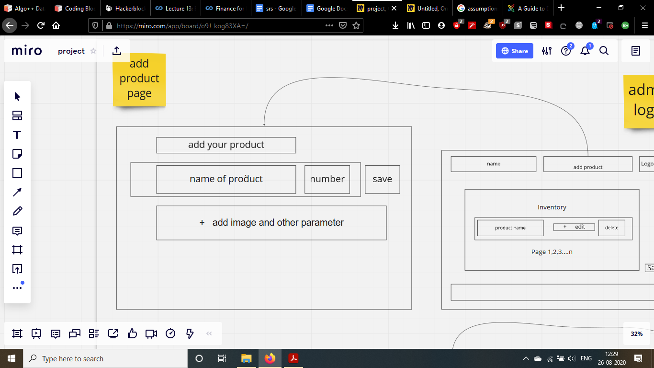

Shopkeepers can edit the amount of product left in the inventory.

**Security Design**

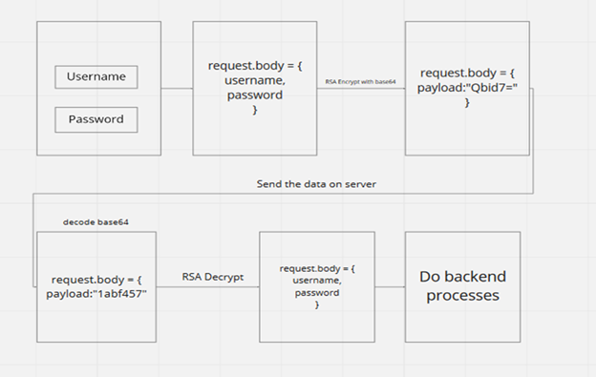

This is the basic security implementation of the website. The form data is securely encrypted with RSA (3072 bit private key) before sending. Hence, data remains encrypted during transmission

# EXPERIMENTS/RESULTS

This is the final website that was developed for this project it can be accessed using the given link

Link: [http://easyshopindia.herokuapp.com**/**](http://easyshopindia.herokuapp.com/)

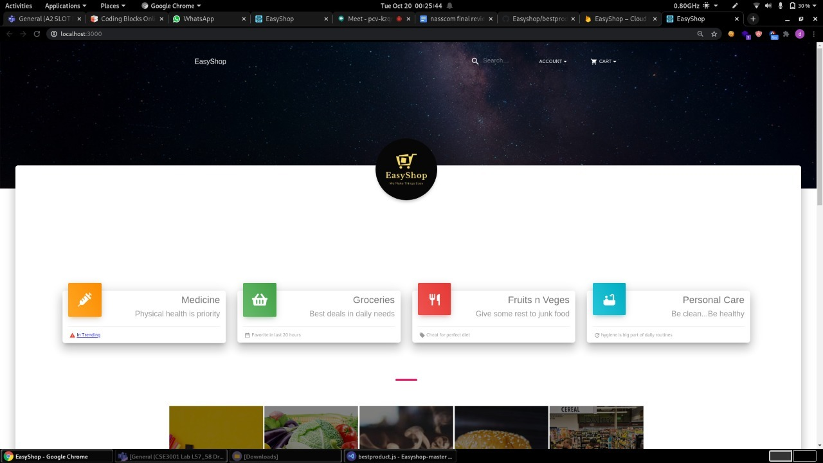

*Home page*

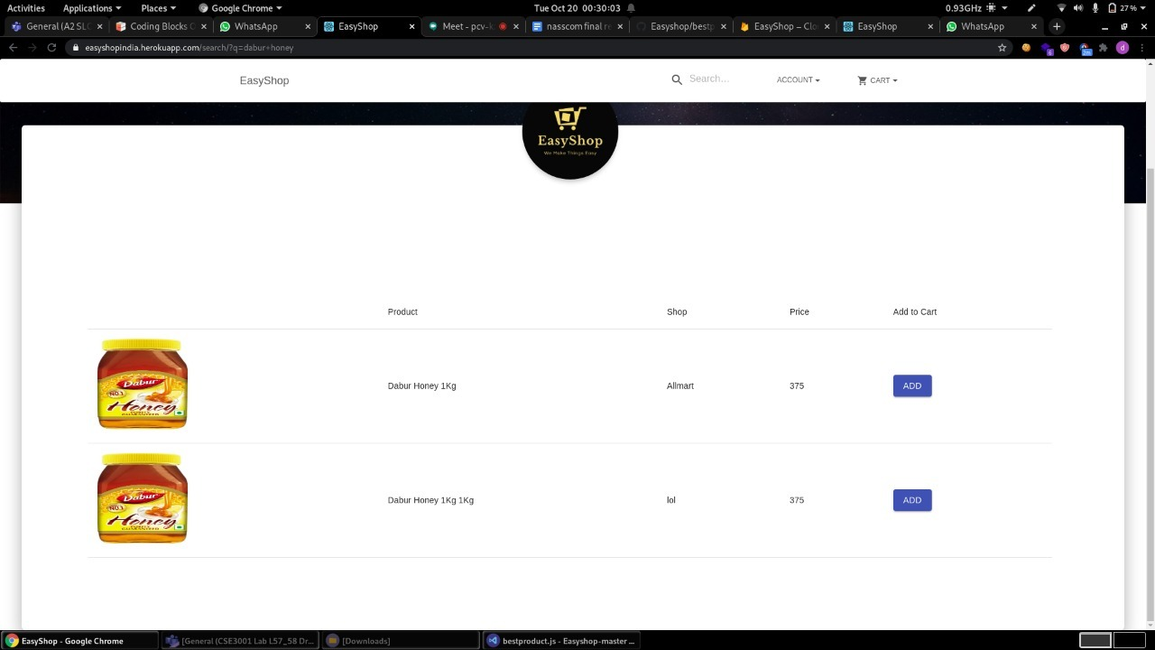

*Search page*

This is the search page. Upon searching for the product, this page will show up with the matched products.

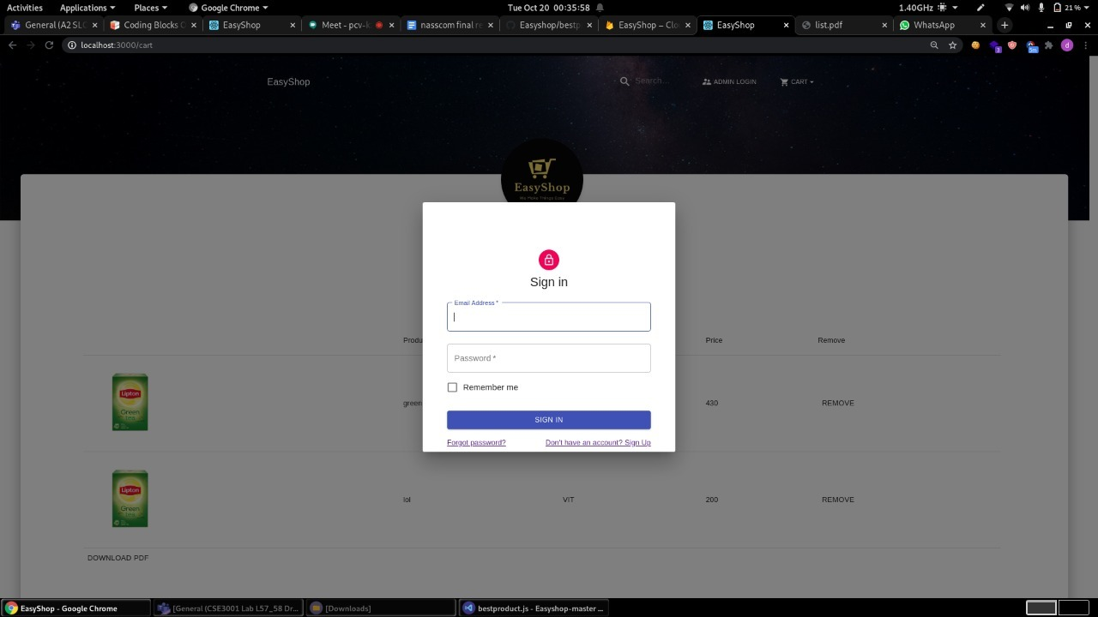

*Admin Login*

The login page where shopkeepers can login to the website to manage their inventory.

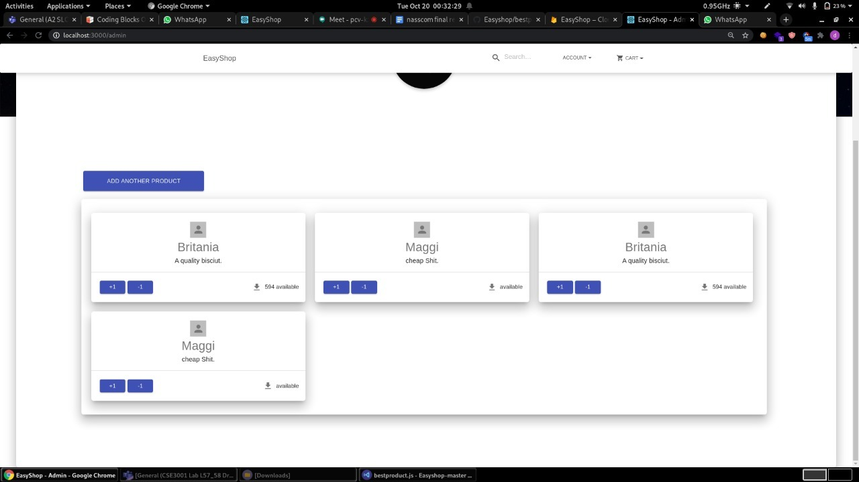

*Admin Inventory panel*

After the shopkeeper logs in, he will see this page. He can update his inventory with this page.

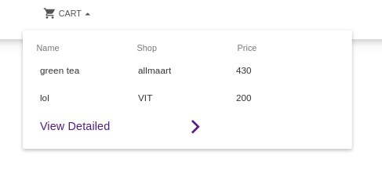 *cart*

This is a quick cart, the user can quickly checkout his cart here instead of having to go to a different page to see the cart.

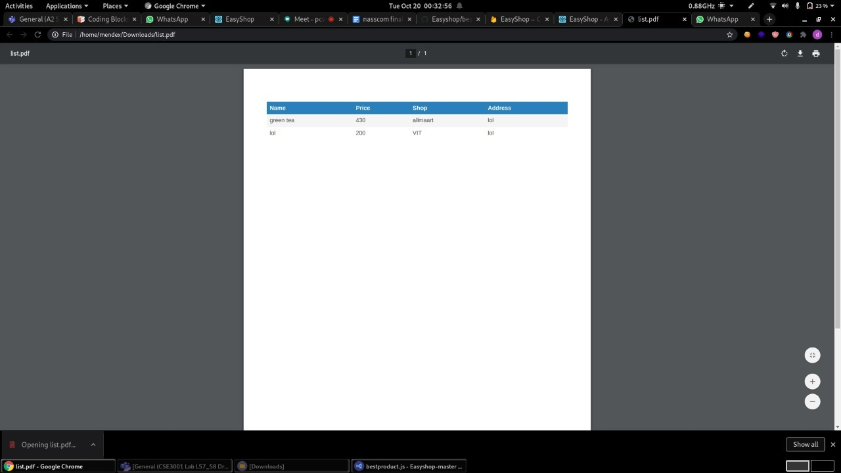

*Checkout*

After the user “checks out”, a pdf will be downloaded giving the approx amount needed for the purchase and other things.

**Security Aspects**

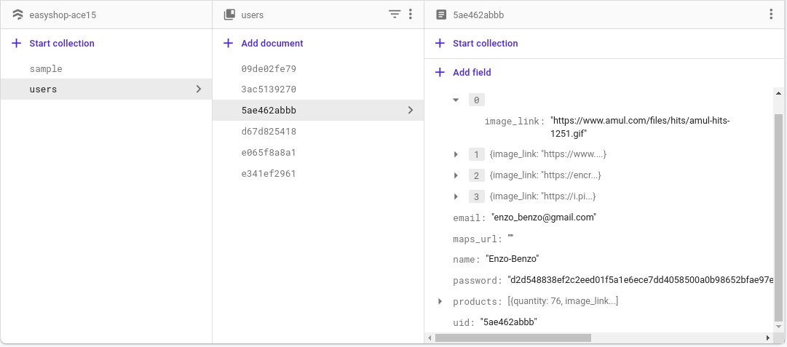

*Hashed Password Stored in Database*

We store our users’ data in hashed format. So if in any case there is database breach, hacker can’t see the details of our user

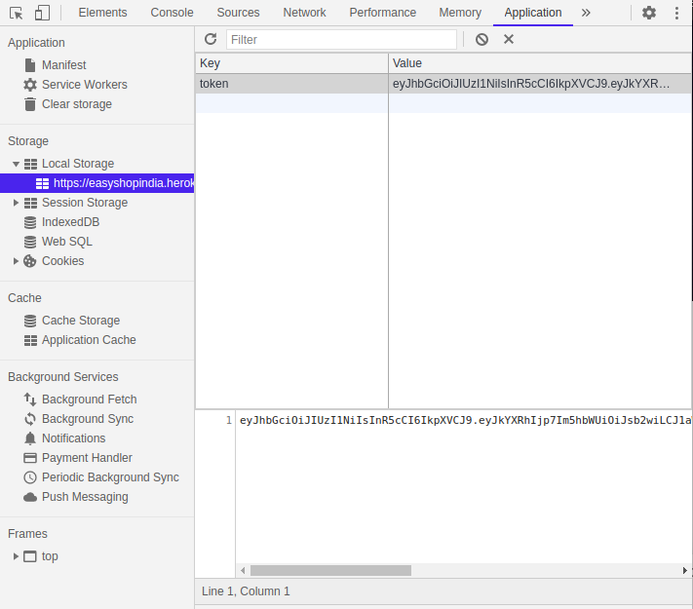

*Encrypted JSON web Token*

We also take care of the request that our website makes. Our website will all request in just one line of “payload”. So it will be very secure in case like the hacker will try to use a burp suite then the hacker can see the only “payload” that is our request to the server.

# CONCLUSION/FUTURE WORKS

**FUTURE WORK:**

future work that can be implemented with the project is integration of more shops and an option for home delivery done by the shop. As in this project, we have developed a web app that facilitates consumers to buy goods from small local retail shops.

An android/IOS application can also be developed as it will help us reach a wider market as surveys show most Indians prefer to use an app over a website for shopping online.

**CONCLUSION:**

This project has successfully made a web app for the given problem statement. And has met most of the requirements stated at the beginning of the project.

The language used is HTML, CSS, and JS and the database used is Google Firebase. It is a web application useful for any person looking to buy groceries. The application is flexible, easy to use with interactive UI.

# REFERENCES

1. Sanchit Aggarwal “Modern Web-Development using ReactJS ” et al. International Journal of Recent Research Aspects ISSN: 2349-7688 Vol. 5, Issue 1, March 2018, pp. 133-137.
2. Tung KhuatKhuat “Developing a frontend application using ReactJS and Redux” 2018
3. Shooks, A., & Hibler, K. (2008). *U.S. Patent No. 7,469,233*. Washington, DC: U.S. Patent and Trademark Office.
4. Domes, S. (2017). *Progressive Web Apps with React: Create lightning fast web apps with native power using React and Firebase*. Packt Publishing Ltd.
5. Tanna, M., & Singh, H. (2018). *Serverless Web Applications with React and Firebase: Develop real-time applications for web and mobile platforms*. Packt Publishing Ltd.
6. Adamousky, G. D., & Graves, G. T. (2009). *U.S. Patent Application No. 12/153,168*.
7. Fedosejev, A. (2015). *React. js essentials*. Packt Publishing Ltd.
8. Zammetti, F. (2020). *Modern Full-Stack Development: Using TypeScript, React, Node. js, Webpack, and Docker*. Apress.
9. Aumasson, J. P., Neves, S., Wilcox-O’Hearn, Z., & Winnerlein, C. (2013, June). BLAKE2: simpler, smaller, fast as MD5. In *International Conference on Applied Cryptography and Network Security* (pp. 119-135). Springer, Berlin, Heidelberg.
10. Singh, S. R., Khan, A. K., & Singh, S. R. (2016, December). Performance evaluation of RSA and elliptic curve cryptography. In *2016 2nd International Conference on Contemporary Computing and Informatics (IC3I)* (pp. 302-306). IEEE.
11. Chanana, N., & Goele, S. (2012). Future of e-commerce in India. *International Journal of computing and business research*.
12. Ray, S. (2011). Emerging trend of e-commerce in India: Some crucial issues, prospects and challenges. *Computer Engineering and Intelligent Systems*, *2*(5), 17-35.